Unit 6 Day 15

Today, we are going to wrap up unit 6 and review everything we have learned this past week and a half.

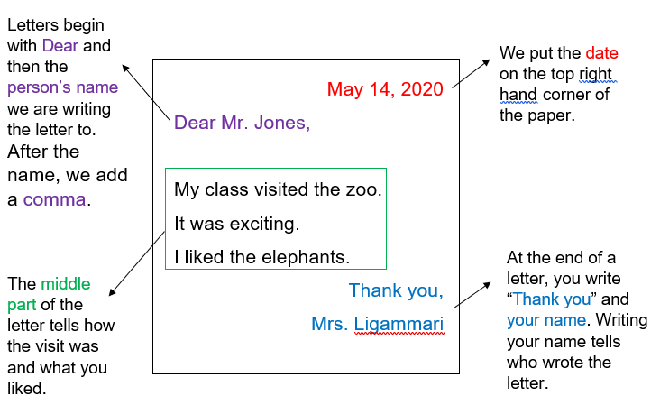When we write a letter, what do we need to include?

Can you say the word **where**?

What sound does **where** start with? /wh/

What 2 letters are at the beginning of **where**?

What sound do we hear in the middle of **where**? /e/

What letter makes this sound?

What sound do you hear at the end of **where**? /r/

What letter makes this sound?

What do you do when you come to a crosswalk?

What do you look for at the crosswalk?

When is it safe is walk across the crosswalk?

Can you say the word **no**?

What sound do you hear at the start of **no**? /n/

What letter is at the beginning of **no**?

What sound do you hear at the end of **no**? /o/

What letter is at the end of **no**?

When we can to ask where something is, how do we ask for directions? How will we start our sentence?

Where is _______ ________?

Can you think of a place that you might need directions to?

What is the difference between was and were? When do we use these words?

We use the word was when we are talking about something that already happened with just one person.

We use the word were when we are talking about something that already happened with more than one person.

Can you use these 2 words in complete sentences?

Activities! You are welcome to do all of these activities but please do at least three of them.

1. Have your child write the word **where** 10 times each.
2. Have your child write the word **no** 10 times each.
3. Have your child practice writing a letter. Have them include everything this is discussed from the example above.
4. Have your child draw a picture of them and a relative waiting at a crosswalk.
5. Have your child write 2 sentences using the word was correctly and 2 sentences using the word were correctly.